**Test Case 0018 (part 1)**

**System:** VirtuCardsClient & VirtuCardsHost

**Description:** Tests to ensure messages are sent only to the intended recipient.

**Severity:** 3

**Instructions**

* Start VirtuCardClient application
* Click the button labeled “Sign In”
* Enter “virtucards01@gmail.com” into the text input labeled “Enter email…”
* Enter “Testing1” into the text input labeled “Enter password…”
* Press the button labeled “Login”
* A window should appear saying “Login Success”
* Press the OK button that appears on that window
* Start VirtuCardHost application
* Repeat steps 2-7 but on the VirtuCardHost application
* The checkbox “Allow Host to Join” should be checked on the host
* Press the Create Game button
* In the VirtuCardClient application enter the 6-character room code found on the host’s screen into the field labeled “Enter Code…”
* Press the Join Game button on the client
* After the name TestCase0001 appears in the player list on the host side, press the Start Game button
* Click the dropdown menu that says “Public chat”

**Expected result:** The dropdown menu should open with the usernames of the players that are in the game that isn’t the player him/herself. Since there is only one person, the only option in the dropdown menu should be “Public chat”

**Test Case 0018 (part 2)**

**System:** VirtuCardsClient & VirtuCardsHost

**Description:** Tests to ensure messages are sent only to the intended recipient.

**Severity:** 3

**Instructions**

1. Start VirtuCardClient application
2. Click the button labeled “Sign In”
3. Enter “virtucards01@gmail.com” into the text input labeled “Enter email…”
4. Enter “Testing1” into the text input labeled “Enter password…”
5. Press the button labeled “Login”
6. A window should appear saying “Login Success”
7. Press the OK button that appears on that window
8. Repeat steps 1-7 but press “Play Anonymously” and ignore steps 3 and 4.
9. Start VirtuCardHost application
10. Repeat steps 2-7 but on the VirtuCardHost application
11. The checkbox “Allow Host to Join” should be checked on the host
12. Press the Create Game button
13. In the VirtuCardClient application enter the 6-character room code found on the host’s screen into the field labeled “Enter Code…”
14. Press the Join Game button on the both clients
15. After the name TestCase0001 and Anonymous#### appears in the player list on the host side, press the Start Game button
16. Click the dropdown menu that says “Public chat” on the TaseCase0001 side

**Expected result:** The dropdown menu should open with the usernames of the players that are in the game that isn’t the player him/herself. The dropdown menu should show “Public chat” and “Anonymous####” on the dropdown menu since there is more than 1 person in the game.

**Test Case 0018 (part 3)**

**System:** VirtuCardsClient & VirtuCardsHost

**Description:** Tests to ensure messages are sent only to the intended recipient.

**Severity:** 3

**Instructions**

1. Start VirtuCardClient application
2. Click the button labeled “Sign In”
3. Enter “virtucards01@gmail.com” into the text input labeled “Enter email…”
4. Enter “Testing1” into the text input labeled “Enter password…”
5. Press the button labeled “Login”
6. A window should appear saying “Login Success”
7. Press the OK button that appears on that window
8. Repeat steps 1-7 but press “Play Anonymously” and ignore steps 3 and 4.
9. Start VirtuCardHost application
10. Repeat steps 2-7 but on the VirtuCardHost application
11. The checkbox “Allow Host to Join” should be checked on the host
12. Press the Create Game button
13. In the VirtuCardClient application enter the 6-character room code found on the host’s screen into the field labeled “Enter Code…”
14. Press the Join Game button on both clients
15. After the name TestCase0001 and Anonymous#### appears in the player list on the host side, press the Start Game button
16. Click the dropdown menu that says “Public chat” on the TaseCase0001 side
17. Click anonymous#### in the dropdown menu
18. Send something in the chat

**Expected result:** After clicking anonymous####, the chat should be set to a private message. When the player sends something after that, the UI of the private message will show up, which just says “(private)” in the red text before the username. That text will show up on the screen of anonymous#### and TestCase0001, but not on the host side.

**Test Case 0018 (part 4)**

**System:** VirtuCardsClient & VirtuCardsHost

**Description:** Tests to ensure messages are sent only to the intended recipient.

**Severity:** 3

**Instructions**

1. Start VirtuCardClient application
2. Click the button labeled “Sign In”
3. Enter “virtucards01@gmail.com” into the text input labeled “Enter email…”
4. Enter “Testing1” into the text input labeled “Enter password…”
5. Press the button labeled “Login”
6. A window should appear saying “Login Success”
7. Press the OK button that appears on that window
8. Repeat steps 1-7 but press “Play Anonymously” and ignore steps 3 and 4.
9. Start VirtuCardHost application
10. Repeat steps 2-7 but on the VirtuCardHost application
11. The checkbox “Allow Host to Join” should be checked on the host
12. Press the Create Game button
13. In the VirtuCardClient application enter the 6-character room code found on the host’s screen into the field labeled “Enter Code…”
14. Press the Join Game button on both clients
15. After the name TestCase0001 and Anonymous#### appears in the player list on the host side, press the Start Game button
16. Click the dropdown menu that says “Public chat” on the TaseCase0001 side
17. Click anonymous#### in the dropdown menu
18. On the host side, click the “Normal chat” dropdown menu
19. Disable the chat
20. Put it back to Normal chat

**Expected result:** After clicking the anonymous#### to set the chat to the private chat, the sign that says “Disable chat” will show up when the host disables the chat. However, when the host normalizes the chat again, the client chat will show up again, and the chat will still be set to private chat.

Pictures

Part 1

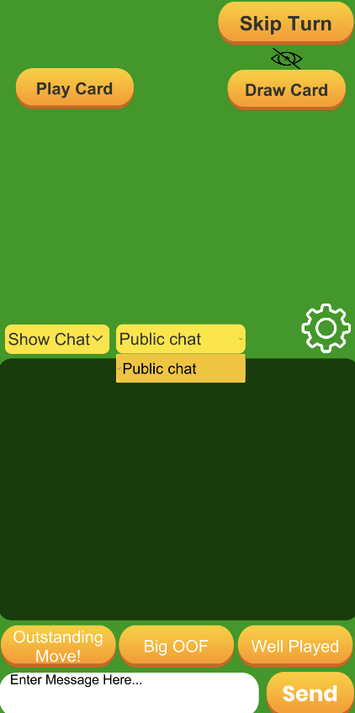

This shows that since I was the only person in the game, it does not give the option to private message anybody else other than the public chat.

Part 2

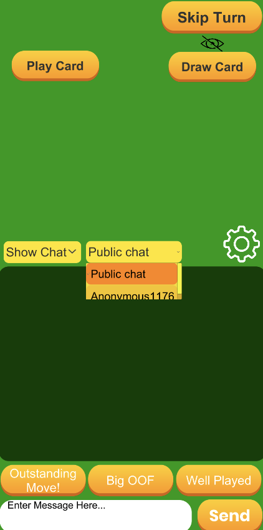

Since there is somebody else in the game, when the user presses the option to private message, there are one other option to private message that person.

Part 3

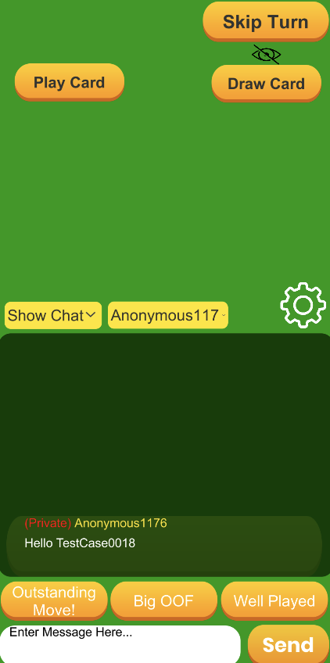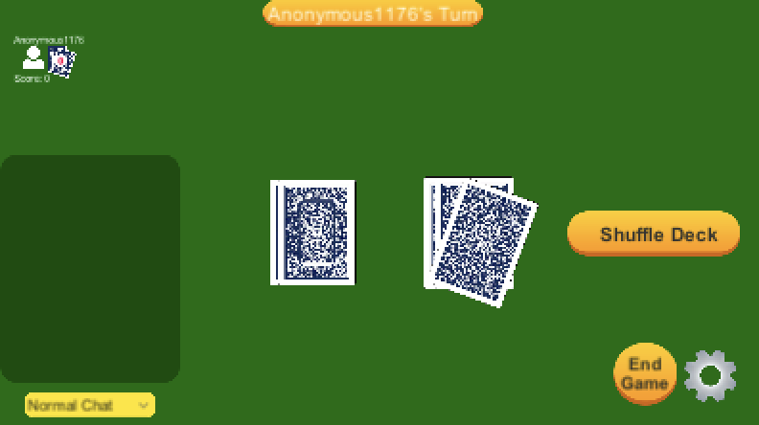

When the option is set to a private message, it shows that “(private)” text in red before the username shows up when a text has been sent. The private text is not shown in the host side, but it is shown in the sender and the receiver’s chat on their client side.

Part 4

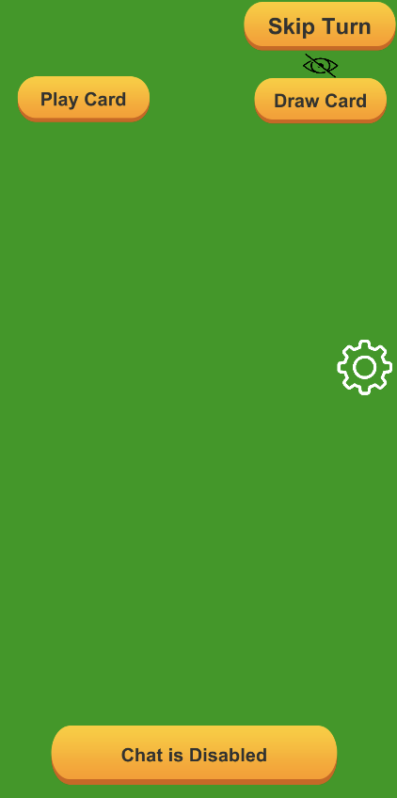

After a private message has been set, the host disables the chat, which as expected, the “Chat is Disabled” sign shows up. When the host normalizes the chat, the option to private chat is still there and instead of going back to the default “Public chat”.